- Concept Generation and Evaluation
Creativity is a great motivator because it makes people interested in what they are doing. Creativity gives hope that there can be a worthwhile idea. Creativity gives the possibility of some sort of achievement to everyone. Creativity makes life more fun and more interesting.—Edward DeBono
When developing a design, it is important to explore many potential solutions and select the best one from them. Too often a single concept is generated and is the only one pursued, the unfortunate result being that potentially better solutions are not considered. When confronted with a problem, engineers must explore different concepts, critically evaluate them, and be able to defend the decisions that led to a particular solution. Two key thought processes employed are creativity and judgment. Creativity involves the generation of novel concepts, while judgment is applied to evaluate and select the best solution for the problem. Creativity and judgment appear to be inherent individual qualities that can’t be taught. That is to some extent true, but with practice and application of formal techniques, they can be improved.
It is important to distinguish between innovation and creativity. Creativity refers to the ability to develop new ideas, while innovation is the ability to bring creative ideas to reality. Innovation is valued by companies since new products and services are often their lifeblood. That is why many make it a priority to hire engineers who can bring creativity to the design process. This chapter addresses creativity, concept generation, and evaluation in design. The first part describes barriers to creative thought, followed by strategies for overcoming them and enhancing creativity. Next, methods for concept generation are presented, followed by techniques for concept evaluation.
Learning Objectives
By the end of this chapter, the reader should:
- Understand the importance of creativity, innovation, concept generation, and concept evaluation in engineering design.
- Be familiar with the barriers that hinder creativity.
- Be able to apply strategies and formal methods for concept generation.
- Be able to apply techniques for the evaluation of design concepts.
  - Creativity
Is creativity something that is inherent in the individual or something that can be learned? It appears that both are true; some individuals are naturally more creative than others, yet people can enhance their creativity with conscious effort and practice. This section examines barriers to creativity, different thinking modes, and strategies for enhancing creativity. One of the ways to spark creativity is to solve puzzles. To get into the creative spirit the reader can try to solve the puzzles presented in Figure 4.1.


(a) (b)
Figure 4.1 (a) The shovel problem. Think of this as a shovel with a coin on the spade. The objective is to move two lines so that the coin is no longer in the spade, but there is still a shovel. (b) The nine dot problem. Draw four connected straight lines that pass through all nine dots.

Barriers to Creativity
James L. Adams, an engineer and former professor at Stanford University, has researched innovation in technical domains. He examined the barriers to creativity and classified them into the following four types: 1) perceptual blocks, 2) emotional blocks, 3) cultural and environmental blocks, and 4) intellectual and expressive blocks [Ada01].
Perceptual blocks are those that prevent people from clearly seeing the problem for what it is. A common perceptual block is the tendency to delimit the problem space, or in other words, to put constraints on the problem that don’t exist. Have you solved the puzzles shown in Figure 4.1 yet? If not, it is possible that you are placing constraints on the problems that don’t exist. Knowing that this is the case, you may want to go back and try again. Another example of a perceptual block is the tendency to stereotype or see a solution to a problem that one is biased to see. This occurs because we have used similar techniques for solving the problem in the past. For example, if you have used a microcontroller to solve a certain type of problem, chances are that you are going to consider using a microcontroller in all related problems in the future. Another perceptual block is the difficulty of isolating the true problem. Three pictures that illustrate this are shown in Figure 4.2. When examining these images, people tend to form a conclusion as to what the content of each one is. Look carefully, as each picture has two equally valid interpretations.

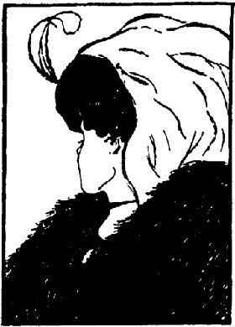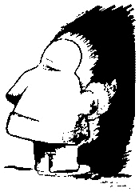
Figure 4.2 Each of the images shown above has two different interpretations. Can you determine what they are?
One of the most common emotional blocks is the fear of failure. People often have creative ideas, but are afraid to express them since they may be criticized or may not have the “correct” answer. It is cliché to hear that you must fail often to succeed, but true. The highly successful product design company, IDEO, that was examined in Chapter 2 takes the approach in concept generation to “fail early and often” in order to succeed [Kel01]. Their design teams are encouraged to develop many seemingly outlandish ideas that are often discarded, but sometimes lead to innovative solutions. Another emotional block is a fear of chaos and disorganization. The creative process challenges engineers, since it is disorganized and not a neat scientific approach to which they are accustomed. Another block is the tendency to critically judge ideas, rather than generate and build upon them. Finally, it takes time for creative ideas to incubate. Most of us can relate to the experience when we could not solve a problem that nagged us for a period of time, followed by that unexpected “Aha!” moment when we identified the solution.
Environmental blocks refer to those things in our environment that limit creative ability. This could be in the form of poor teamwork where members distrust each other and criticize each other’s ideas. In the workplace, this could be due to autocratic management that resists new ideas. There are also cultural biases against creativity. There is a bias against creativity as an approach to problem solving in the engineering field. This is usually based upon the reasoning that there is a single correct solution to a problem and creativity is an excuse for poor engineering. It is true that creativity and brainstorming alone do not solve engineering problems—the concepts generated need to be scrutinized using engineering principles to become viable innovations.
The final block that Adams identified is that of intellectual and expressive. In an engineering context, this means that the designer needs to have an understanding of intellectual tools that are applied to solve problems. For example, mathematics is a universal language for expressing and solving scientific problems. Specific examples in ECE are languages that describe the characteristics of systems such as functional, logical, and state behaviors. Examples in digital design are truth tables (input, output behavior) and state diagrams (stimulus-response). In the domain of electronics design, a functional approach (input, output, and function) is commonly used. Chapters 5 and 6 present tools for modeling the behavior of ECE systems.

Vertical and Lateral Thinking
Edward DeBono is the father of a field known as lateral thinking, which offers a different perspective on the barriers to creativity. Lateral thinking is contrasted to what is known as the vertical thinking process [Deb67, Deb70]. Engineers tend to be vertical (or convergent) thinkers, meaning that they are good at taking a problem and proceeding logically to the solution. This is typically a sequential linear process, where the engineer starts at the highest level and successively refines elements of the design to solve the problem. This is usually based upon experience solving similar problems and conventional tools that are employed in that particular area.
The objective of lateral (or divergent) thinking is to identify creative solutions. It is not concerned with developing the solution for the problem, or right or wrong solutions. It encourages jumping around between ideas. In the words of DeBono “The vertical thinker says: 'I know what I am looking for.' The lateral thinker says: 'I am looking but I won't know what I am looking for until I have found it.' ” The field of lateral thinking is characterized by puzzles of the following type found at Paul Sloane’s Lateral Thinking Puzzles website [http://dspace.dial.pipex.com/sloane]:
A body is discovered in a park in Chicago in the middle of summer. It has a fractured skull and many other broken bones, but the cause of death was hypothermia.
A hunter aimed his gun carefully and fired. Seconds later, he realized his mistake. Minutes later, he was dead.
A man is returning from Switzerland by train. If he had been in a non-smoking car he would have died.
The objective in these puzzles is to develop plausible scenarios that explain how each of the above situations could have happened. A solution for the first example is that a person stowed away in the wheel compartment of a jet airliner. While in flight he froze and died of hypothermia. When the plane prepared to land, it lowered its landing gear, causing the body to fall to the park, fracturing his skull, and breaking his bones. Can you develop plausible scenarios that describe each of them?
Vertical thinking focuses on sequential steps toward a solution and tries to determine the correctness of the solution throughout the process. This is very different from lateral thinking where there is nonlinear jumping around between steps and there is no attempt to discern between right and wrong. As such, lateral thinking is more apt to follow least likely paths to a solution, whereas vertical thinking follows the most likely paths. The goal in lateral thinking is to develop as many solutions as possible, while vertical thinking tries to narrow to a single solution.
Lateral thinking is appropriate for the concept generation phase. So should concept generation and brainstorming be done by the individual or by a team? DeBono and Osborn [Osb63] conclude that creativity is more effective by individuals than by teams. However, Osborn also points out that there is great value in applying creativity in teams, since it provides a place for the team to work together on problems and see other perspectives. Our anecdotal observations of student design teams supports this—group brainstorming is effective for developing concepts, new product ideas, new features, and different ways to combine technologies. This is because in groups, ideas are readily built upon by other team members. More mathematical, technical, and theoretical breakthroughs tend to be the work of the lone genius. Examples of this are the Theory of Relativity (Einstein), Boolean Logic (Bool), and Shannon’s Sampling Theorem. We have also observed that novice designers, who do not have much experience in concept generation, can benefit greatly from group brainstorming techniques.

Strategies to Enhance Creativity
There are valuable strategies that can be employed to enhance the creative process. The body of research on the subject is very large and key points are summarized as follows:
- Have a questioning attitude. One of the keys is to have a questioning attitude and challenge assumptions. The willingness to do this generally decreases as people age. Young children are highly creative and are constantly questioning everything, with questions such as “Why do trees have leaves?” or “Why is the sky blue?” Asking basic questions stimulates creativity and is applicable to technical designs. When examining a design with a microcontroller, ask questions such as “Is there a way to replace the microcontroller?”, “Are there other features that I can achieve with the microcontroller?”, and “Is there a better microcontroller that can be used?”
- Practice being creative. Research shows that people can improve their creative ability through conscious effort. For example, try solving the puzzles presented in this chapter and in the end of the chapter problems. Be conscious of things that bother you (“pet peeves”) in your everyday life and try to develop new solutions for them.
- Suspend judgment. It is easy to criticize and immediately dismiss ideas, so it is important to defer judgment and be flexible in thinking. Seemingly outlandish ideas can lead to other concepts that are valuable solutions. The opportunity for new solutions is curtailed if ideas are immediately judged and discarded. Creative concepts can be developed by taking a concept and modifying it or combining it with other seemingly unrelated concepts.
- Allow time. The creative process needs time for incubation. The human mind needs time to work on problems, so set aside time to reflect on the problem and to allow it to incubate so that the “Aha!” moment of discovery can happen.
- Think like a beginner. New solutions often come from novices. The reason is that novices don’t have preconceived ideas as to the solution for a problem. Experience is a double-edged sword—it allows one to quickly solve problems by drawing upon pre-existing solutions, but can inhibit creativity. If confronted with a new problem that bears similarity to one encountered in the past, then it is likely that the new solution will bear similarity to the old one. If everyone else is it doing it one way, consider the opposite.
Many creative ideas arise from novel combinations and adaptations of existing technology. SCAMPER, an acronym for Substitute, Combine, Adapt, Modify, Put to other use, Eliminate, and Rearrange/Reverse, can be used as a guide to systematically generate creative concepts. The SCAMPER principles are valuable in brainstorming and are described below:
- Substitute. Can new elements be substituted for those that already exist in the system?
- Combine. Can existing entities be combined in a novel way that has not been done before?
- Adapt. Can parts of the whole be adapted to operate differently?
- Modify. Can part or all of a system be modified? For example, size, shape, or functionality.
- Put to other use. Are there other application domains where the product or system can be put to use?
- Eliminate. Can parts of the whole be eliminated? Or should the whole itself be eliminated?
- Rearrange or Reverse. Can elements of the system be rearranged differently to work better? This is different from substituting in that the elements of the system are not changed, but rearranged or ordered differently to create something new. In terms of reversal, are there any roles or objectives that can be reversed?
SCAMPER is a modification of a set of questions that was originally posed by Osborn [Osb63] and was modified to its form above by Michalko [Mic91].
  - Concept Generation
After the problem is defined, the next step is to explore concepts for the solution. It is unlikely that a design team will have reached this stage without some ideas for solving the problem, but it is important to fully explore the design space. Ullrich and Eppinger [Ull03] identify the following phases of concept generation – search internally, search externally, and systematically explore. Each is considered in turn.
External searching was covered to a great extent in Chapters 2 and 3, which addressed conducting background research and benchmarking. Methods of external searching are:
- Conduct literature search.
- Search and review existing patents.
- Benchmark similar products.
- Interview experts.
Internal searching is done by the team members via methods such as brainstorming. The team members need have to have a common problem definition for this to be effective. Understanding the tradeoffs using requirement analysis methods in Chapter 3 is also valuable, as overcoming tradeoffs leads to innovative solutions. Furthermore, the team should decompose larger problems into sub-problems and the attack the sub-problems individually. Chapter 5 addresses the process of problem decomposition.

DILBERT® by Scott Adams
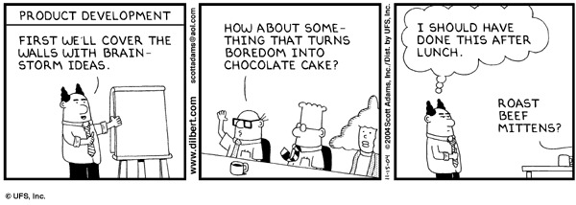

Figure 4.3 Wally brainstorming. (Dilbert © United Feature Syndicate. Reprinted by permission.)
The most well-known method of internal searching is brainstorming. Group brainstorming is effective for generating many concepts in a short period of time. Experienced design teams are known to generate hundreds of concepts in an hour. Traditional brainstorming is not highly-structured—though a facilitator helps—and employs five basic rules:
- No criticism or judgment of ideas.
- Wild ideas are encouraged.
- Quantity is stressed over quality.
- Build upon and modify the ideas of others.
- All ideas are recorded.
Many novice design teams struggle with unstructured brainstorming and more formalized approaches, such as brainwriting and the Nominal Group Technique, can be of benefit. The steps of brainwriting are:
- The team develops a common problem statement that is read out loud.
- Each team member writes their ideas down on a card and places it in the center of the table.
- Other team members then take cards from the pile and use other’s ideas to generate new ones or build upon them, keeping in mind the principles of SCAMPER. Alternatively, members can each generate an idea, write it on a card, and then pass it to another team member. Each member then builds upon the idea passed to them.
Brainwriting 6-3-5 is a variation where the objective is to have six people, develop three ideas in five minutes. The optimal number of people for the exercise is thought to be six, although it is not necessary. Each person generates three ideas in five minutes, and clearly describes it using sketches and written descriptions on paper. At the end of five minutes, each team member passes their ideas to another team member. The next person reviews the ideas of their teammate and adds three more by building on them, developing new ones, or ignoring as necessary. This process continues until all members have reviewed all papers.
In the Nominal Group Technique (NGT) [Del71] each team member silently generates ideas that are reported out in a round-robin fashion so that all members have an opportunity to present their ideas. Concepts are selected by a multi-voting scheme with each member casting a predetermined number of votes for the ideas presented. The ideas are then ranked, discussed further, and voted upon again if necessary. The steps of NGT are as follows:
- Read problem statement. It should be read out loud by a team member (the facilitator).
- Restate the problem. Each person restates the problem in their own words to ensure that all members understand it.
- Silently generate ideas. All members silently generate ideas during a set period of time, typically 5–15 minutes.
- Collect ideas in a round-robin fashion. Each person presents one idea in turn until all ideas are exhausted. The facilitator should clarify ideas and all should be written where the entire team can view them.
- Summarize and rephrase ideas. Once the ideas are collected, the facilitator leads a discussion to clarify and rephrase the ideas. This ensures that the entire group is familiar with them. Related ideas can be grouped or merged together.
- Vote. Each person casts a predetermined number of votes, typically three to six, for the ideas presented. The outcome is a set of prioritized ideas that the team can further discuss and pursue.
To systematically generate concepts, the problem is decomposed sub-functions and solutions are sought for the sub-functions. A concept table, demonstrated in Table 4.1, is a tool for identifying different combinations, arrangements, and substitutions. The table headings identify functions to be achieved in the design, while the entries in the corresponding column represent potential solutions. Novel products or solutions are generated by combining elements from each of the columns, which are identified in the table by circled elements. The solutions can be in the form of a single element selected from each column, or as in the example shown, multiple elements selected from each column.
Table 4.1 A concept table for generating ideas for a personal computing system. The potential solution is identified by the combination of circled elements.
User Interface | Display | Connectivity & Expansion | Power | Size
Keyboard | CRT | Serial &  Parallel | Battery | Hand-held, Fits in pocket
Touchpad | Flat Panel | USB | AC Power | Notebook size
Handwriting Recognition | Plasma | Wireless Ethernet | Solar Power | Wearable
Video | Heads-up Display | Wired Ethernet | Fuel Cell | Credit Card Size
Voice | LCD | PCMCIA | Thermal Transfer | Flexible in shape
Modem /
Telephone

Based on the concepts circled in Table 4.1, one can imagine a personal computing system that has the following features: 1) is wearable with different credit card size components placed on the body and in clothing to make it comfortable to use; 2) is powered by a combination of solar cells, fuel-cells, and from thermal heat generated by a person’s body; 3) has a microphone and camera integrated in the user’s clothing for interface to the system, as well as a flexible foldable keyboard for typing that is stored in a pocket; 4) has a heads-up display integrated with the user’s eyeglasses or baseball hat; and 5) has a miniature earpiece microphone used for communication. While the above example focused on novel combinations and substitutions, the concept table can also be used to examine the possibility of eliminating ideas. For example, the table inherently assumes that a display will be used. However, it should also be asked if it is absolutely necessary in the design.
Another example is shown in Table 4.2, where the objective is to identify design concepts for a temperature measurement and display device. There are three main elements to the proposed solution: the thermal sensing method, circuitry that converts the sensor information (temperature) to a voltage, and a display unit that converts the voltage to a displayed temperature. Note that the table implies a three-stage architecture, thus concepts are generated within that framework. There may be completely different architectures that are better.
Table 4.2 Concept table for a temperature measurement device.
Thermal Sensing | Conversion to Voltage | Display
Thermistor | Op Amp Design | Seven-Segment LEDs
RTD | Transistor Designs | LCD
Thermocouple |  | Analog Dial Indicator

A related tool is a concept fan, which is a graphical representation of design decisions and choices. An example concept fan for the temperature measuring device is shown in Figure 4.4. Design decisions are identified by circles; solutions are indicated by squares. In this example, more options are shown than in Table 4.2. Concepts are generated by selecting among the different solution blocks.
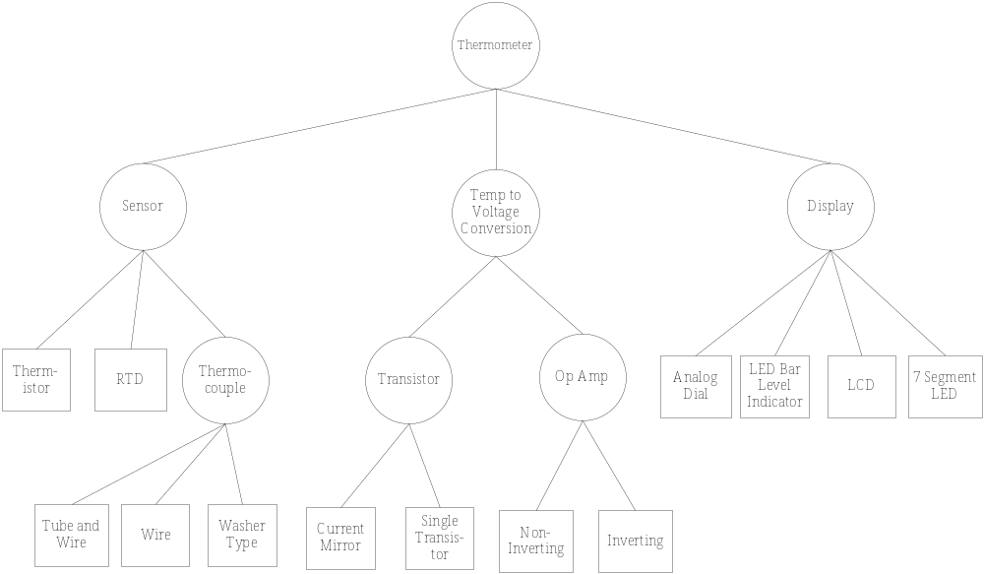
Figure 4.4 A concept fan for the temperature measuring device. The circles represent the choices to be made and the squares represent potential solutions to the choices.
  - Concept Evaluation
The concepts generated are evaluated to determine which are the most promising to pursue. The designer should exercise engineering judgment and use the customer needs and technical factors to drive the decision. This process is shown in Figure 4.5, where the user needs, concepts, and engineering consideration serve as inputs to a decision process to ranks the concepts. A point of caution—some of the methods presented generate numerical scores for comparing concepts, leading one to potentially believe that the quantitative results are infallible. Keep in mind that the inputs are based on qualitative and semi-quantitative assessments and can be geared to select a preconceived notion of the solution. It is important to maintain flexibility of thinking, to challenge assumptions, and ultimately determine the best concept.
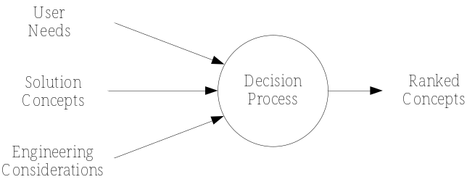
Figure 4.5 Process for concept evaluation.

Initial Evaluation
The concepts generated should be initially reviewed and those that are completely infeasible discarded. Some of the reasons a concept may be deemed infeasible are that it may be far too costly, will take too long to develop, or involve too much risk. In many cases it may be deemed that using cutting-edge technology represents an unacceptable risk. Concepts that clearly cannot meet the engineering requirements should also be discarded. Care should be taken not to completely eliminate ideas that may have merit, as conditions change and some concepts that were previously thought unrealistic may become viable in the future.

Strengths and Weaknesses Analysis
Another form of evaluation is to complete a strengths and weaknesses analysis of the potential solutions. Table 4.3 demonstrates the application of this analysis applied to an experimental design project for testing of the Intel 1000XF card (examined in Chapter 2 (Example 2.2) and Chapter 3 (Table 3.2)). In order to test the card under different operating temperatures, a method of heating the card and holding its temperature fixed during the experiment was needed. The two solutions compared were to use a contact heating element or to place the card in an environmental test chamber. In this particular example, the temperature chamber solution was ultimately selected due to the need for a uniform temperature distribution. The strength and weakness analysis is good for examining problems of moderate complexity. It suffers in that it does not require uniform criteria for comparison. To make the method more quantitative, relative scores for the strengths (plus factors) and weaknesses (minus factors) can be assigned and used to score the concepts.
Table 4.3 A strengths and weaknesses analysis of proposed methods for heating an Intel 1000XF card to be used in lifetime testing. [Ese03].
Method | Strengths | Weaknesses
Contact Heating | - Simplest design  - Could be used internally to computer | - Does not create uniform temperature  - Hard to control temperature
Temperature Chamber | - Uniform temperature  - Greater control over temperature | - Must be external to computer  - More difficult to design  - Expensive

Analytical Hierarchy Process and Decision Matrices
In the Analytical Hierarchy Process, design alternatives are compared against pre-selected criteria, such as the engineering or marketing requirements. AHP is covered in detail in Appendix B and was first applied in Chapter 2 for project selection. The reader is encouraged to review Appendix B as necessary. The end result of AHP is a decision matrix is shown in Table 4.4, where the criteria are listed in the leftmost column with the associated weighting factors (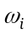) quantifying the relative importance of the criteria. The body of the matrix contains design ratings, 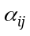, that reflect the technical merit of each of the j^{th} design options relative to i^{th} criterion. The total score, S_{j}, for each design option is computed as a weighted summation of the design ratings and weighting factors.
Table 4.4 A decision matrix for the Analytical Hierarchy Process.
 |  | Design Option 1 | Design Option 2 |  | Design Option n
Criteria 1 | 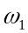 | α₁₁ | α₁₂ |  | α_{1n}
Criteria 2 | 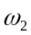 | α₂₁ | α₂₂ |  | α_{2n}
Criteria m | 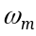 | α_{m1} | α_{m2} |  | α_{mn}
Score |  | 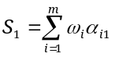 | 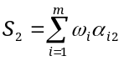 |  | 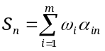

The application of AHP is demonstrated for the design of an electronic circuit for measuring temperature, by producing a voltage signal that is directly proportional to temperature.

Step 1: Determine the Selection Criteria
Assume that the criteria for comparing the concepts are high accuracy, low cost, small size, and availability of parts for manufacture.

Step 2: Determine the Criteria Weightings
- Assume that the criteria were ranked using pairwise comparison and weights computed (see Appendix B) as shown in Table 4.5.
Table 4.5 Pairwise comparison matrix.
 | Accuracy | Cost | Size | Availability | Weights
Accuracy | 1 | 5 | 3 | ¼ | 0.42
Cost | 1/5 | 1 | 2 | ¼ | 0.12
Size | 1/3 | ½ | 1 | 1 | 0.12
Availability | 4 | 4 | 1 | 1 | 0.34

Step 3: Identify and Rate Alternatives Relative to the Criteria
Three candidate solutions are shown in Figure 4.6. Each acts as a constant current source that drives a temperature measurement device (RTD). The resistance of an RTD varies with temperature, and when driven by a constant current, I, produces a voltage, V_{T}, that varies proportionally with temperature. Each circuit supplies a constant current of I=1mA.
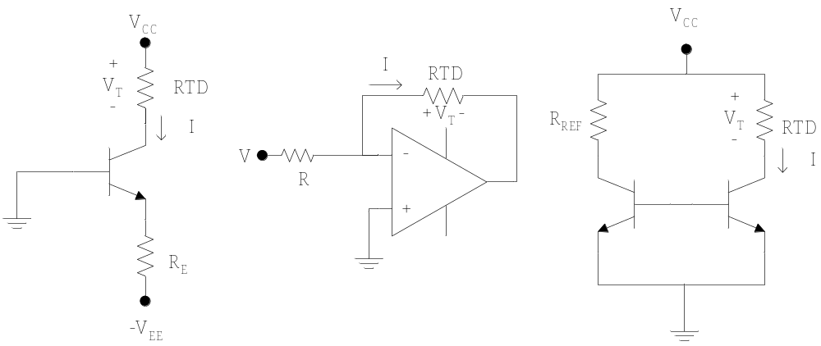
1: Single Transistor 2: Inverting Op Amp 3: Current Mirror
Figure 4.6 Candidate solutions for temperature measurement.
The accuracy of each design was evaluated by a sensitivity analysis using a SPICE circuit simulation package assuming 10% resistors. The deviation of the output voltage (maximum deviation from nominal) for the three designs is 9.2%, 1.3%, and 1.9% respectively. Since the objective is to minimize the deviation, the following rating metric is used
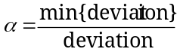. (1)
This produces the following normalize design ratings for accuracy: 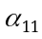 = 0.08, 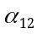 = 0.55, and 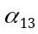 = 0.37.
The parts costs are the following: resistors = $0.05, bipolar junction transistors (BJTs) = $0.15, op amps = $0.35, and RTDs = $0.25. Using a measure for cost similar to (1) gives following normalized cost ratings for the three options respectively: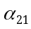 = 0.41, 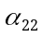 = 0.28, and 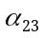 = 0.31.
Assume that to manufacture each circuit on a printed circuit board requires the following dimensions: design 1 = 1 in², design 2 = 1.56 in², and design 3 = 2.25 in². The objective is to minimize size, and againusing a measure analogous to (1) for the required space to manufacture each produces the following normalized decision ratings: 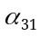 = 0.48, 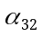 = 0.31, and 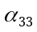 = 0.21.
Assume that the parts have an in-stock availability of 95%, 70%, 90%, and 80% of the time for the resistors, BJTs, RTDs, and op amps respectively. A measure for the overall availability of parts to manufacture each design is required. One way to measure this is to compute the probability that a design will be able to be manufactured based upon the past history of part availability. This is found by multiplying the availability of all individual components needed for the design:
P(design 1 can be produced) = (0.95)(0.90)(0.70) = 0.60
P(design 2 can be produced) = (0.95)(0.90)(0.80) = 0.68
P(design 3 can be produced) = (0.95)(0.90) (0.70)(0.70) = 0.42
This produces the following normalized decision ratings for availability: 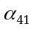 = 0.35, 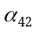 = 0.40, and 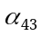 = 0.25.

Step 4: Compute Scores for the Alternatives
The decision matrix is built and the overall weighted scores for the alternatives are computed as shown in Table 4.6.
Table 4.6 The decision matrix.
 |  | Single BJT | Op Amp | Current Mirror
Accuracy | 0.42 | 0.08 | 0.55 | 0.37
Cost | 0.12 | 0.41 | 0.28 | 0.31
Size | 0.12 | 0.48 | 0.31 | 0.21
Availability | 0.34 | 0.35 | 0.40 | 0.25
Score |  | 0.26 | 0.44 | 0.30

Step 5: Review the Decision
Remember that this is a semi-quantitative method. The final ranking indicates that design options 1 and 3 are quite similar, while both are inferior to option 2.

Pugh Concept Selection
Pugh Concept Selection is a method of comparing concepts against criteria, similar to what we saw with a decision matrix. It is different in that it has a simpler scoring method and it is an iterative process. The steps of Pugh Concept Selection are:
- Select the comparison criteria, usually the engineering or marketing requirements.
- Determine weights for the criterion.
- Determine the concepts.
- Select a baseline concept that is initially believed to be the best.
- Compare all other concepts to the baseline, using the following scoring method: +1 better than, 0 equal to, -1 worse than.
- Compute a weighted score for each concept, not including the baseline.
- Examine each concept to determine if it should be retained, updated, or dropped. Synthesize the best elements of others into other concepts wherever possible.
- Update the table and iterate until a superior concept emerges.
An example of a Pugh Concept Selection matrix is shown in Table 4.7.
Table 4.7 Pugh Concept Selection matrix.
 |  | Option 1  (Reference) | Option 2 | Option 3 | Option 4
Criteria 1 | 4 | - | 0 | 0 | +1
Criteria 2 | 5 | - | +1 | -1 | 0
Criteria 3 | 2 | - | -1 | 0 | +1
Criteria 4 | 1 | - | +1 | +1 | -1
Score |  | - | 4 | -4 | 5
Continue? |  | Combine | Yes | No | Combine
  - Project Application: Concept Generation and Evaluation
The following advice is provided for teams in the concept generation and evaluation phase:
- Set aside time specifically for concept generation and evaluation and take it as a challenge to identify as many concepts as possible.
- Search externally, including literature reviews and patent searches.
- Search internally using brainstorming, brainwriting, or the Nominal Group Technique. Effective teams generate many concepts in a brainstorming session.
- Examine solutions for the entire design, for sub-functions of the design, and for individual components (such as integrated circuit selection). The techniques in this chapter can be combined with design methods presented in Chapters 5 and 6.
- Utilize SCAMPER, concept tables, and concepts fans as tools to facilitate and document concept generation.
- Critically and objectively evaluate concepts against common criteria.
- Clearly identify the concept(s) selected and the rationale for selection.
  - Summary and Further Reading
In the design process, it is important to creatively generate different concepts for a solution to a problem. This is followed by an evaluation of concepts to determine which are the most promising. This chapter identified barriers to creativity and provided strategies for enhancing creative ability. The concepts of vertical and lateral thinking were introduced, and their impact on the design process was explored. Methods of concept generation, including brainstorming, concept tables, and concepts fans were presented. Finally, methods for critically evaluating concepts (strength/weakness analysis, Analytical Hierarchy Process, and Pugh Concept selection) were presented.
There are many references that examine creativity and concept generation. Adams [Ada01] is a good reference for creativity and problem-solving with a technical bent. Alex Osborn was an advocate of creativity and developed two readable works that address the creative process, the need for creativity, and strategies for enhancing it [Osb48, Osb63]. Edward DeBono is another well-known authority in the field and has produced many works on lateral thinking and creativity [Deb67, Deb70]. Paul Sloane has published numerous books with lateral thinking puzzles [Slo91, Slo93, Slo94]. TRIZ [Alt99] is a more advanced and complex approach to concept generation, that centers around resolving tradeoffs in a problem. It is fairly complex and may be considered by more advanced teams.
  - Problems
  - Consider the nine dot puzzle shown in Figure 4.1 (b). Draw three connected straight lines that pass through all nine dots.
  - Consider the six sticks shown below. Rearrange the sticks to produce four equilateral triangles (the sticks cannot be broken).

  - Consider the fish shown below made of eight sticks and a coin for the eye. The objective is to make the fish face the other direction by moving only the coin and three sticks.
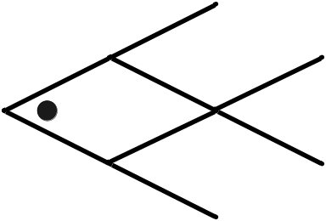
  - For each of the following lateral thinking puzzles, develop a plausible solution (from Paul Sloane’s Lateral Thinking Puzzles [http://dspace.dial.pipex.com/sloane]):
  - A man walks into a bar and asks the barman for a glass of water. The barman pulls out a gun and points it at the man. The man says 'Thank you' and walks out.
  - A woman had two sons who were born on the same hour of the same day of the same year. But they were not twins. How could this be so?
  - Why is it better to have round manhole covers than square ones?
  - A man went to a party and drank some of the punch. He then left early. Everyone else at the party who drank the punch subsequently died of poisoning. Why did the man not die?
  - Legislation was passed to allow handguns in the cockpits of passenger airliners to prevent hijacking. Brainstorm to develop concepts that prevent anyone other than the pilot from using the handgun.
  - Imagine if scientists and engineers were able to develop a technology that would allow people to be transported from any place on earth to another instantaneously. Brainstorm to determine the potential impact this would have on society.
  - Student advising at many colleges and universities is seen as an area that can be improved. Brainstorm to develop ideas as to how student advising could be improved at your college or university.
  - In your own words, describe what a concept table and a concept fan are.
  - Consider the problem solved in Section 4.3.2. For this example assume that:
- The following is the result of the paired comparison.
 | Accuracy | Cost | Size | Availability
Accuracy | 1 | 1/3 | 2 | ½
Cost | 3 | 1 | 5 | 1
Size | 1/2 | 1/5 | 1 | 2
Availability | 2 | 1 | ½ | 1
- The parts costs are the following: resistors = $0.05, bipolar transistors (BJTs) = $0.10, op amps = $0.35, and RTDs = $0.25.
- The parts have an in-stock availability of 99%, 90%, 85%, and 70% of the time for the resistors, BJTs, RTDs, and op amps respectively.
- Everything else is the same as presented in Section 4.3.2.
Compute the rankings of the design options using a weighted decision matrix of the type shown in Table 4.5.
    - Project Application. Utilize the methods in this chapter to generate concepts for your particular design problem. Critically evaluate the concepts generated using one or more of the techniques presented in the chapter that is appropriate for the problem. Section 4.4 provides guidance on how to conduct this process and document the results.

